How to Install Squid & Squid Gaurd

Step :1 Install Squid

Login the pfsesne administration user page. Go to system menu to navigate the package option..

To locate the Squid packages list click the plus button on the right side of the package to start installation …
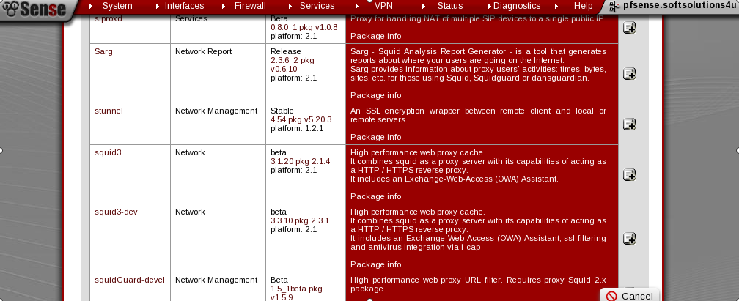

The package manager will automatically download install the package.
Step :2 Configure the squid proxy

After the squid proxy has been installed we should configure the squid proxy general settings.

Go to the service → to select the proxy server and configure the following options:

1. Enable squid proxy

2. proxy insterface

3. Transparent proxy

4. Server port

5. Access Control

6. Cache Memt

7. Administraror Email

8.log

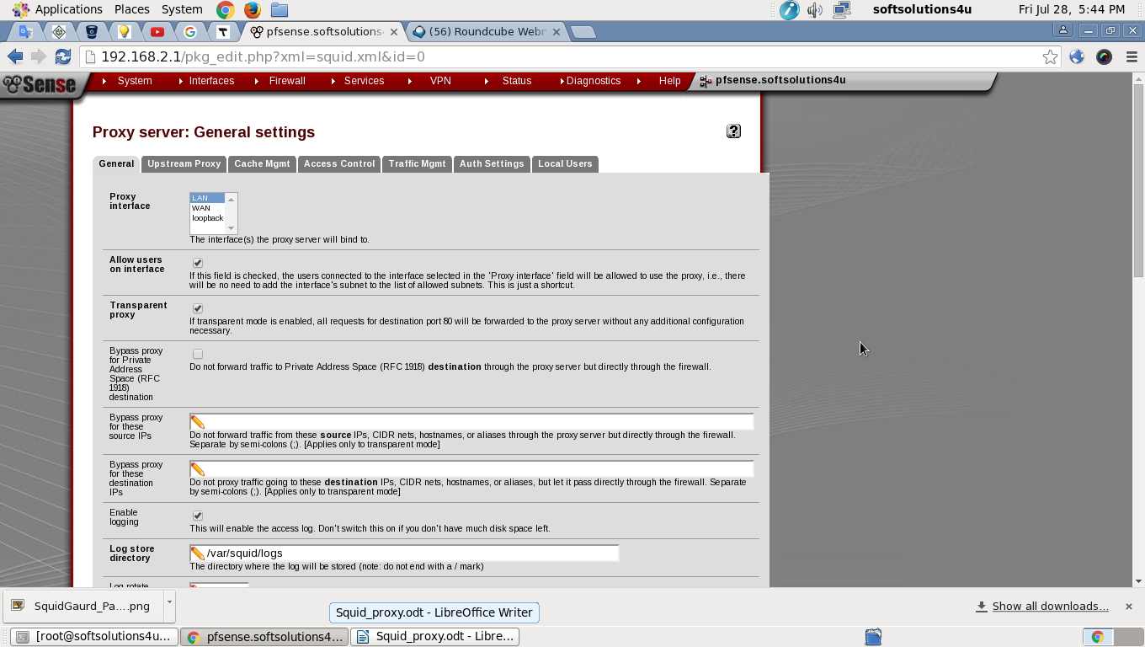

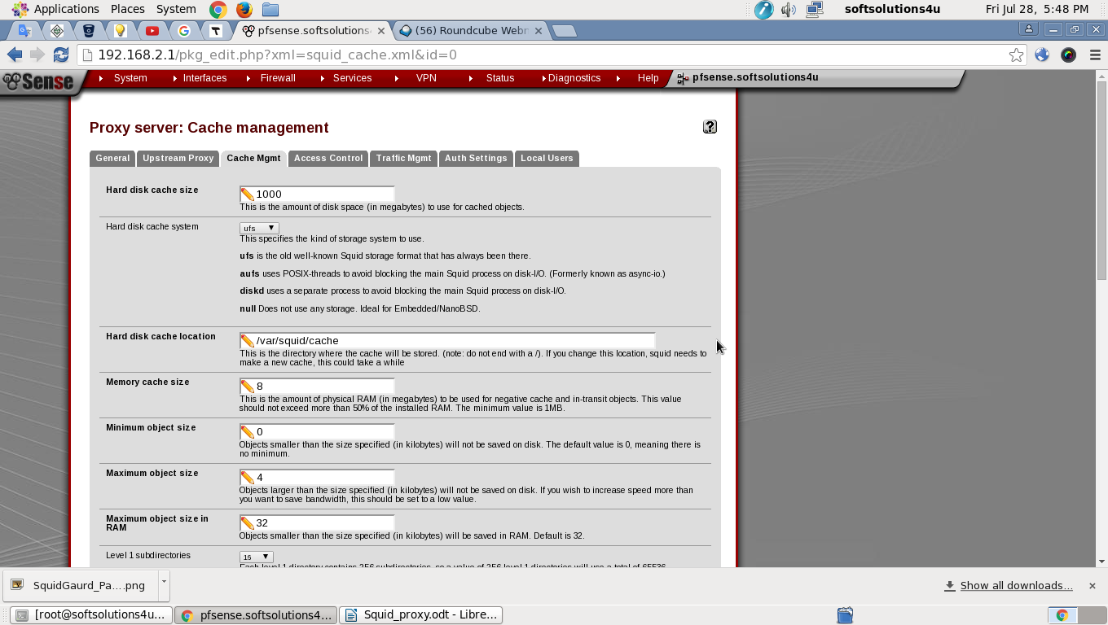

Save and the rest of the settings keep default has squid proxy server.

Install squidGaurd
Step 1: Install squidgaurd

Go to system menu to navigate the package option

To locate the Squidguard packages list click the plus button on the right side of the package to start installation ...
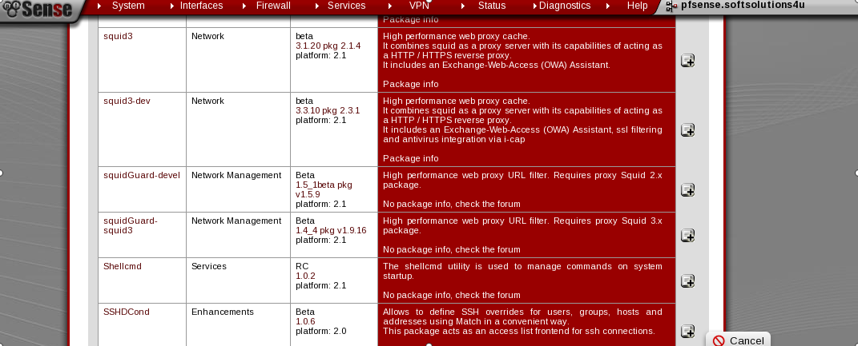
The package manager will automatically download install the package.

Step 2: Enable a Blacklist

Go to service → To select the squid proxy and to click on the check box to enable the blacklist.
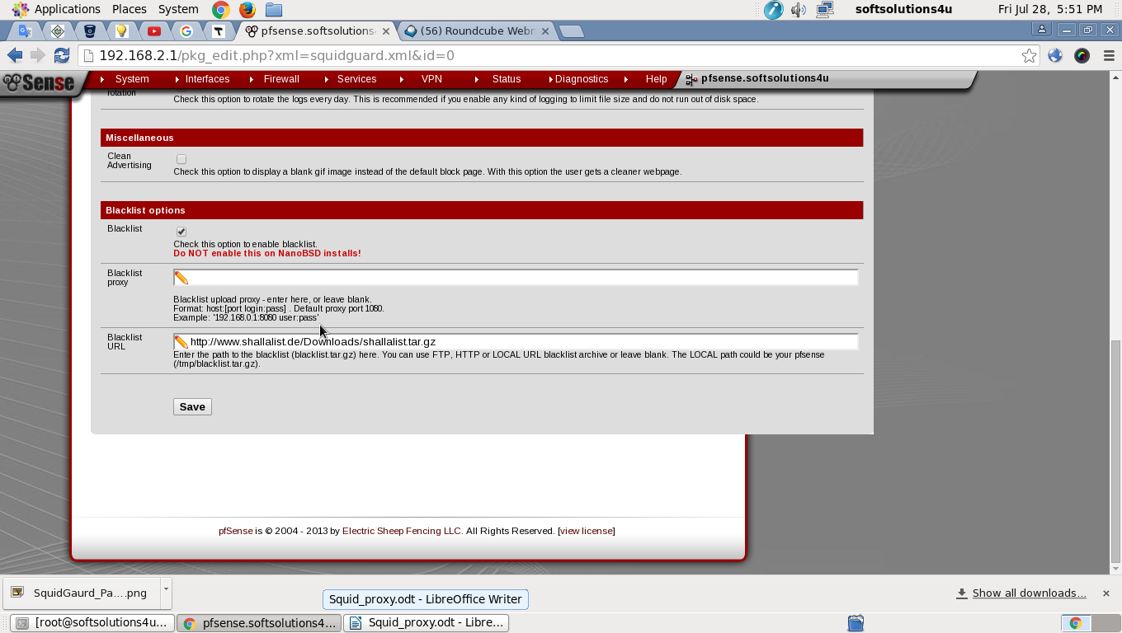
Step 3: Configure Blacklist package
We can use own blacklist or download a one of the public available blacklists on the web sites.

Go to the service → select the squidGaurd and select the Blacklist option than upload the public Blacklists follow the process..
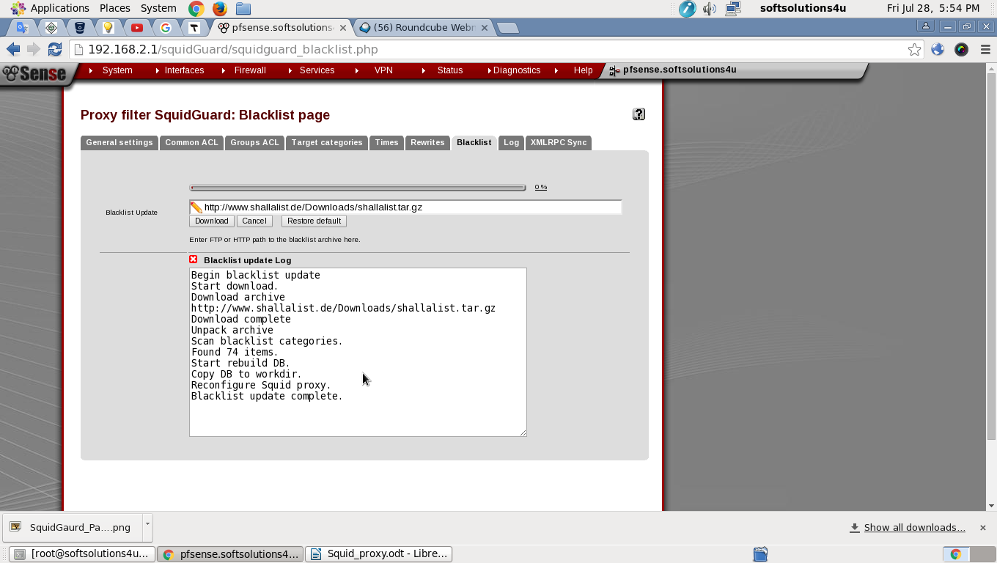
Step 4: Configure ACL

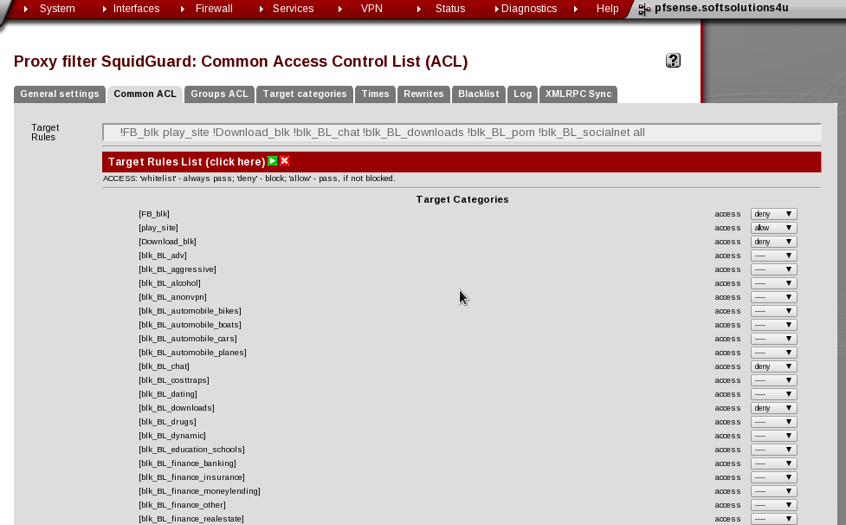
After uploading the blacklist, we have configure the which type categories should allowed, blocked and whitelisted. to select the Common acl tab under the list of settings. It will apply the lan interface of users.

Step 5: Excluding the URLs from the Blacklist

If we need to allow the some of the sites under the blacklist. We can create the new target category
added the list of domains or URL’s that should not be blacked
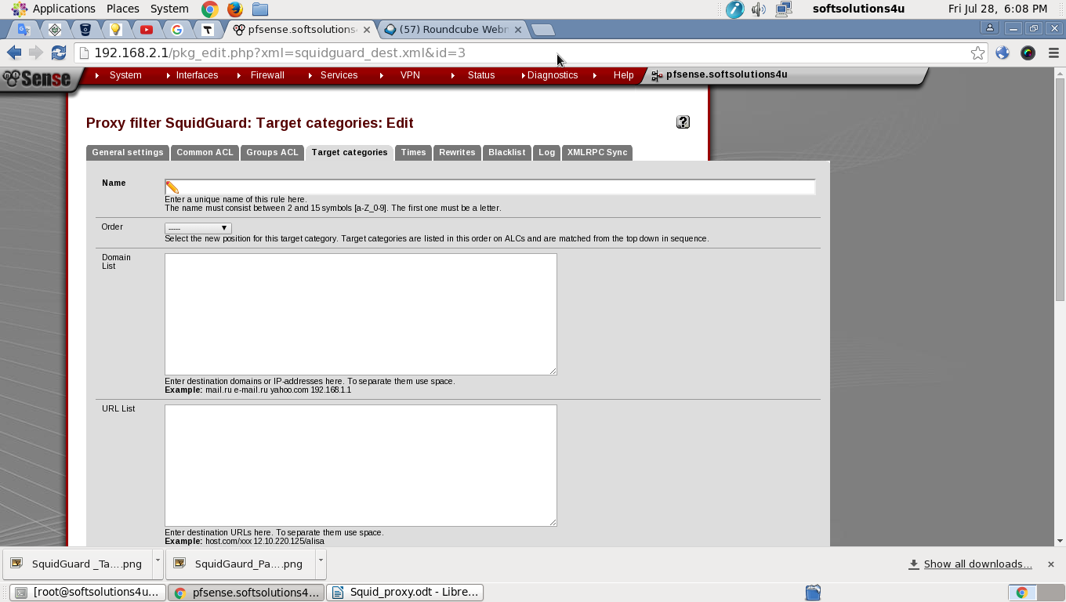

To click on the target category tab and then click the plus symbol to add a new target category. The target category can filter the URL, domain name, expression. List of the sites & sub sites will grant the access. Finally click on save.

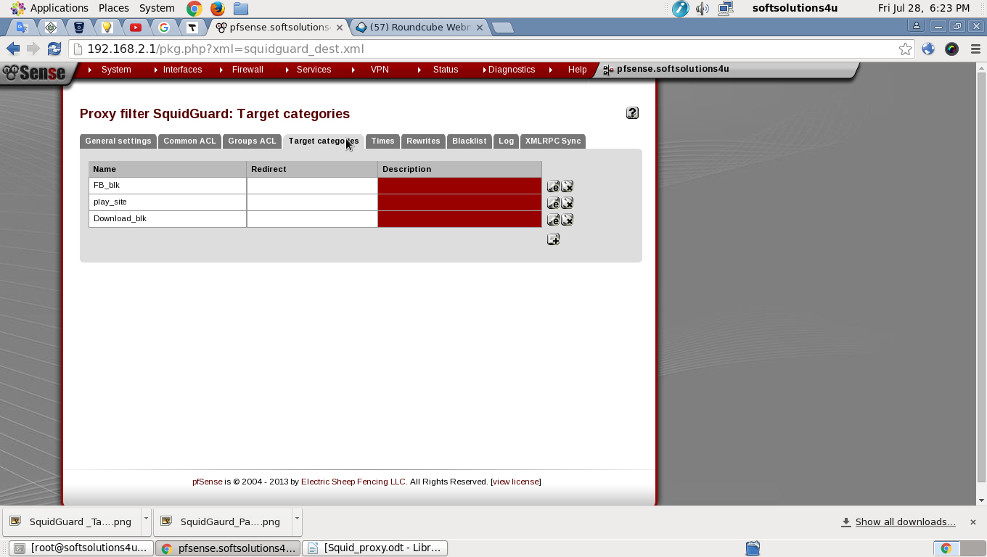

Then go to the common or group ACL tab and select the action of whitelist for that new catetory.the same process for additional site to our blacklisted.
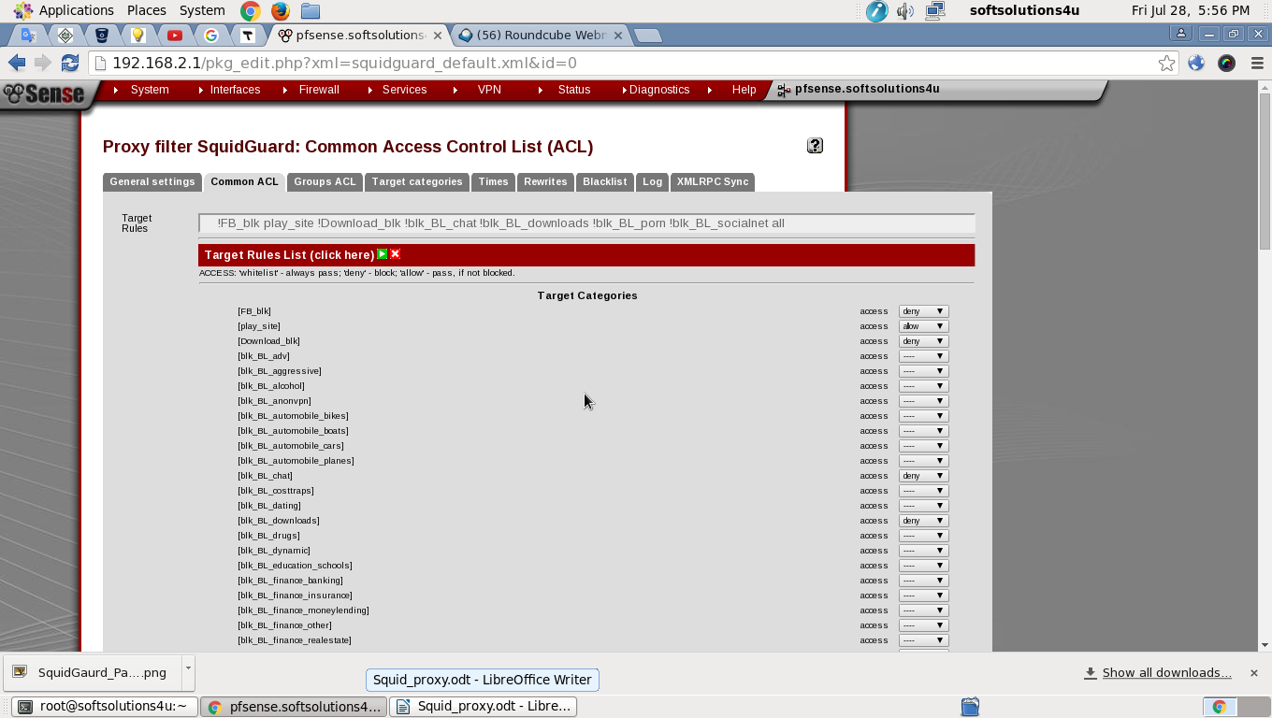

Now we have access the social and blocked sites, it’s showing proxy denied Error. Finally we have successfully blacked the sites, domain, and untrusted sites.

